HISTORY LESSON PLAN
STAGE 1 HISTORY
YEAR LEVEL: 11
SUBJECT: History- 90 Minute Lesson
PREPARED BY: Miss Olivia Rose
TITLE: Life in the Trenches-World War One
OVERVIEW/ANNOTATION:
The aim of this lesson is for students to experience what life was like for soldiers in the trenches in World War One. They will gain this understanding through re-enacting a battle scene in the trenches in theatrical conditions (lights off/ battle sounds in background) with the teacher taking upon the role of a military commander and narrator. Students will also gain this understanding through a reflection activity as well as a PowerPoint of pictures, facts, information and maps. Students will watch a light hearted video and listen to some poetry on the trenches. They will then put themselves in the shoes of the soldiers in the trenches by writing a letter home to their families/wives or parents.
KEY WORDS:
Trench Warfare
No Man’s Land
Zigzagging Trenches
Trench Foot
Gangrene
EDUCATIONAL STANDARDS ADDRESSED:
This lesson is based upon the SACE stage 1, year 11, SACE 2014 Subject Outline for History.
Knowledge and Understanding
KU1 Explanation of how particular societies in selected periods and places have been shaped by both internal and external forces.
KU2 Identification and explanation of historical concepts.
Inquiry and Analysis
IA1 Application of hypotheses and/or focusing questions to guide historical inquiry.
IA2 Analysis and evaluation of sources.

Reflection
The specific feature is as follows:
R1 Understanding and appreciation of the role of particular individuals and groups in history.
Communication
The specific features are as follows:
C2 Use of subject-specific language and conventions.

AIMS OF THE LESSON:
The aim of the lesson is to give students a deep understanding of what life in the trenches was like in WW1. This lesson will guide the students in understanding the concept of trenches, why they were used, how successful they were, the weapons used and the experience for soldiers living in the trenches.
OBJECTIVES/LEARNING OUTCOMES:
On completion of the lesson, students should be able to:
- Describe Trench Warfare
- Describe No Man’s Land
- Have a thorough understanding of life in the trenches- health risks, danger, daily routine, battle warfare,
- Have an understanding of where the trenches were located.
- Understanding of how the trenches were designed/why they were designed like that.
- Impact trenches had on WW1.
- Impact of life in the trenches for the soldiers.
- Weapons used.
ESSENTIAL QUESTIONS:
What is trench warfare? Why were trenches designed/used? What was No Man’s Land? What was life in the trenches like for the soldiers?
BACKGROUND KNOWLEDGE:
It is assumed that the students have prior basic knowledge of WW1 and warfare tactics.
MATERIALS NEEDED:
- Masking tape
- 2 types of coloured paper (scrunched up and made into balls)
- PowerPoint (Trench Warfare) teacher has already made.
- Internet access

- Videos:
- http://www.youtube.com/watch?v=K5pfYpZf4Ac
- http://www.youtube.com/watch?v=uRccyPLNnl0
- https://www.youtube.com/watch?v=vH3-Gt7mgyM&list=PLwCd_jgvjTjQzP7Q9REbcqJNJuyzhJzC0
- 30 copies of the poem ‘The Spirit’ by Woodbine Willy.
- 30 copies of ‘the letter’ instructions for activity 5.
DIFFERENTIATION:
Activities in this lesson are designed to cater for all seven learning styles:
- Visual (power point)
- Oral (teacher talking during power point/activities/battle scene).
- Verbal (letter writing).
- Kinaesthetic (physical re-enactment of battles in trenches).
- Logical (mathematical equations/percentages of those killed/etc….working out in relation to students ‘killed’ in re-enactment battle).
- Social (group work in activity 2/question time, battle activity).
- Solitary (letter writing and quite time).
ACTIVITIES:
- Activity one: trench battle re-enactment (25 minutes). R1 & C2
- Activity two: reflection activity and questions- group work (10 minutes) IA1
- Activity three: PowerPoint and teacher talking (15 minutes). KU1 & KU2 & C2
- Activity four: video and poem (10 minutes) IA2
- Activity five: letter writing and poem (30 minutes) IA1 & C2
- Activity six: homework ‘design your own trench’ C2
ASSESMENT:
FORMATIVE:
- Participation in battle re-enactment
- Participate in group work
- Answering questions
- Writing letters
- Writing a poem
SUMMATIVE:
- Homework sheet- design your own trench
RESOURCES:
WW1 Trench Display with Lighting.
http://www.youtube.com/watch?v=K5pfYpZf4Ac
WW1 Battle Sounds.
http://www.youtube.com/watch?v=uRccyPLNnl0
“Good luck everyone” – Blackadder- BBC.
https://www.youtube.com/watch?v=vH3-Gt7mgyM&list=PLwCd_jgvjTjQzP7Q9REbcqJNJuyzhJzC0
“The Spirit” by Woodbine Willy.
http://www.oucs.ox.ac.uk/ww1lit/education/tutorials/intro/trench/trench.html
Excerpt from the diary of Colonel Joseph Hyde Pratt, page 79.
http://trenchwarfareworldwar1.weebly.com/living-conditions.html

POWERPOINT PHOTOS:
Soldiers emerge from a trench and go over the top into battle during the First World War
A http://www.dailymail.co.uk/news/article-2226235/Historian-Andrew-Robertshaw-builds-60ft-long-First-World-War-TRENCH-Surrey-garden-highlight-plight-frontline-Tommies.html#ixzz2yTK1dT1h

French Soldier standing in a muddy trench, WWI. (circa 1916)
(Photo by Hulton Archive/Getty Images)

http://history1900s.about.com/od/worldwari/a/Trenches-In-World-War-I.htm
The primitive bayonet was still used in World War I. The bayonet is simply a long knife attached to the end of the rifle.

http://allquietonthewesternfrontworld.blogspot.com.au/2012/11/wwi-weaponry-bayonets.html
Machine gun pointing up

http://nataliewise1.wordpress.com/category/uncategorized/page/2/
Early Design of Trench
http://history1900s.about.com/od/worldwari/a/Trenches-In-World-War-I.htm
Classic design of the trenches in and out of the trench

http://dianaoverbey.wordpress.com/2012/01/13/trench-construction-in-world-war-i/
Trench Layout
http://www.historyonthenet.com/WW1/trenches.htm
Map of Trenches
http://merryfarmer.net/2012/01/page/2/

TRENCH WARFARE WW1
Procedure:
Activity One: (25 minutes)
- (Prior teacher set-up) The class will begin with an action activity as the first activity. The class will have the desks turned on their sides and pushed into two straight lines in the middle of the classroom. Masking tape will be lined to demonstrate the trenches and the battle ground. Coloured paper will be rolled into balls and divided into two different coloured piles. One pile will be place behind each desk.
- (students enter class) When the students enter the class, they will be divided into two groups: An allied power and a Central Power. I will then tell them to sit with their groups on one side of the two rows of desks in the classroom.
- Once the students are in their positions, I will tell the students to think about what they have learnt so far about WW1 and place themselves in the feet of the soldiers in the trenches of the battlefield. The lights will then be turned off and war sounds (http://www.youtube.com/watch?v=K5pfYpZf4Ac [this video will also be used as a background display with lights and sound effects]
- The students will lie down and crouch in their positions; the aim will be to put the students in the soldier’s shoes. I will recreate the scene by recounting…..
“40 million people died during WW1-many happened in the trenches…just like where you are lying now…. You are a WW1 soldier, your life isn’t easy, and you could lose your life at any second. This is a terrifying thought, you are only 18….too young to die you say….life is boring, you could be sitting for days on end waiting for a battle to ensue. However boredom is the least of your worries, rats, shellfire, catching diseases and body lice are to mention a few of your daily problems. You may be a soldier that is injured….your lying in filthy, rat and germ infested conditions, your leg may have to amputated…or worse….try disobeying your commanders orders…..boom….you’re dead. The gas masks on your back are a continuous reminder you could be gassed at any minute…..let alone the sound of German planes hovering over you over clear night….the luxury of sleep and food are in the past. You have been lying in these conditions for weeks, you’re exhausted, freezing and starving….all you want to do is go home…..
- I will now take on the order of a military commander yelling “STAY DOWN! KEEP LOW! DO YOU WANT TO BE KILLED!” …. I will then show some students the paper balls or their “artillery” and allow them to attack their enemies…… this could involve firing from their trenches or crossing the classroom into ‘no man’s land’ as the battle grounds were known as. Students that are hit by the paper balls will be told to lie down as they have been ‘killed’ or ‘injured’.
- This battle will continue for another minute or two. The battle will then seize while I instruct the students to plan their tactics with the surviving students. Remembering that the trenches are hard to manoeuvre through with their zig zag shape and muddy soils. The students that have been ‘killed’ must lie there. The battle will again start for a few minutes until seized.
- As this happens I will read out the real life letters excerpts from soldiers that fought in the trenches. For example:
- "August 9,
1918, Friday. … The Reward of the Kootie- A British
officer was going
through the front line trench, when he stooped over and
reached back of his
neck to pick off a "kootie" that was particularly
irritating. Just as he got him off, a bullet passed immediately over his neck… I
know of no way to
reward you except to put you back where you were and let you
keep on
biting.' This he did."
From the Diary of Colonel Joseph Hyde Pratt, page 79.
- I will now draw the student’s attention to those lying on the floor because they have been ‘killed in battle’. I will highlight to the students: “Medical services were not as advanced as todays; a minor injury could kill you. Gangrene alone killed 44% of America’s trench causalities. Death by diarrhoea was also a huge killer let alone exposure to the cold weather of below 0 degrees. 10% of fighting soldiers were normally killed in each battle, what is the percentage of soldiers today that lost their life” (get students to work out and answer) [numeracy] “those that had been killed would lie in no man’s line until the front line moved…..by then they were often unnoticeable. “
- I would close the activity with the students sitting in their positions, I would then play (http://www.youtube.com/watch?v=uRccyPLNnl0) this is a 2 minute video with the same battle sounds in the backdrop but show pictures of the soldiers in the trenches, trench foot, life in the trenches etc. I would tell the students to sit in silence and take in what they have just experienced and sit in silence to reflect and respect the sacrifices the soldiers in the trenches made.
Activity Two: (10 minutes)
I will ask the students their feelings/thoughts/what they learnt in this activity? (They can make small groups and answer these questions which I will hand out) They can then tell the whole class their experiences and how this experience would have been for the soldiers?
- How did this experience feel? Did it bring up emotions for you? Did you feel like you gained a real life experience of the fear and adrenaline that the soldiers would have felt in the trenches?
- We only used scrunched up balls of fire as our weapons, how do you think the soldiers would have felt using real weapons and killing people (sometimes even their own/friendly fire)?
- How do you think waiting in the trenches for weeks would have affected the soldiers as they awaited battle?
Activity Three: (15 Minutes)
I will turn the light back and ask the students to set up the desks in order again. I will then explain a brief outline to the class why trenches were used/ what battles/ how they were used etc. I would explain it through this power point:
P1. As we have just learnt, Trench warfare was crucial in defining the WW1, however no combatants expected it. As the power of modern weapons emerged it soon became clear that machines such as artillery and the machine gun were too dangerous to be used in the open.
P2. The first trenches were just unconnected holes in the ground. Yet they soon developed into complex systems in the ground. Behind the front lines of trenches lay secondary trenches which were built into zig zag patterns that helped prevent the enemy intruding the trenches and protected soldiers from the blasts of the enemy shells. The trenches were usually less than 2 metres deep and were built up with one metre of sandbags or wooden duckboards. The trenches also had dugouts which sheltered the troops and allowed the soldiers to see above the sandbags to shoot and observe the enemy with periscopes.
P3. Most of the time spent in the trenches was waiting on attacks, improving defences, writing letters and sentry duty. Unit’s stages raids in which they captured prisoners to gain vital information, this could vary from hundreds of men to only a few. The units were often rotated to give soldiers rest time from the front line. Like we just re-enacted, the men went ‘over the top’ when an attack was ordered, the ground would often churn into craters of mud making movement slow. The effect of this could be terrible and cause the loss of units in just minutes.
P4. The first trenches were built on the Western Front on September 15, 1914. They were used from the winter of 1914 to the spring of 1918. The distance they covered stretched from the North Sea coast of Belgium southward through France to the southmost point in Alsace, the Swiss border. During the war, the trenches stretched over 25,000 miles, in which 12,000 were occupied by the allies and the rest by the central powers.
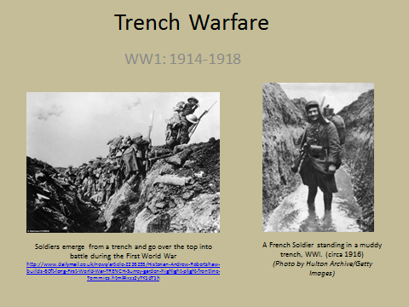
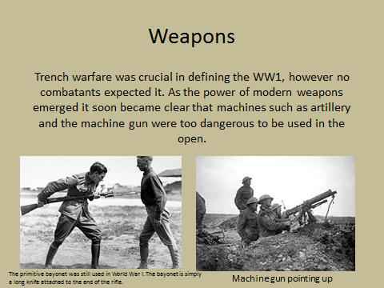

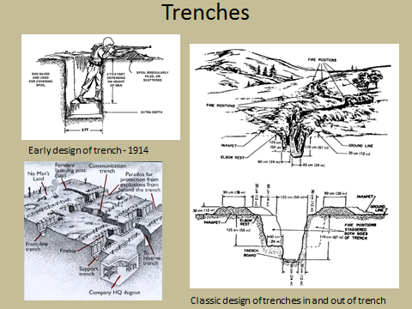
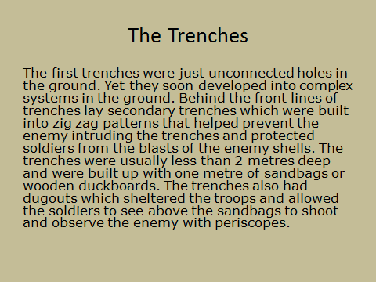
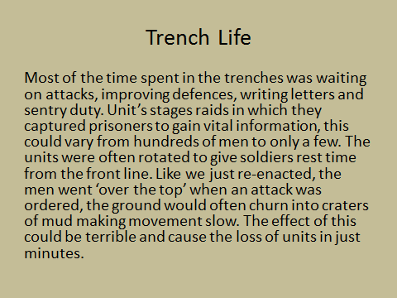
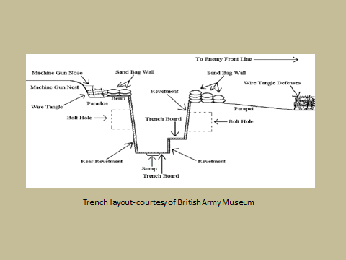
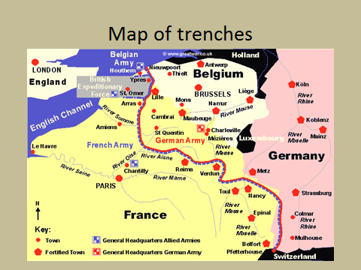
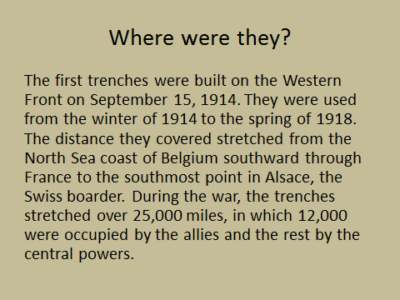
Activity Four: (ten minutes)
As a breather, the students will watch
“Good luck everyone” – Blackadder- BBC
https://www.youtube.com/watch?v=vH3-Gt7mgyM&list=PLwCd_jgvjTjQzP7Q9REbcqJNJuyzhJzC0
(I will block out the “f” word)
I will then read this poem on life in the trenches: this will connect to the following activity.

The Spirit
When there ain't no gal to kiss you,
And the postman seems to miss you,
And the fags have skipped an issue,
Carry on.
When ye've got an empty belly,
And the bulley's rotten smelly,
And you're shivering like a jelly,
Carry on.
When the Boche has done your chum in,
And the sergeant's done the rum in,
And there ain't no rations comin',
Carry on.
When the world is red and reeking,
And the shrapnel shells are shrieking,
And your blood is slowly leaking,
Carry on.
When the broken battered trenches,
Are like the bloody butchers' benches,
And the air is thick with stenches,
Carry on.
Carry on,
Though your pals are pale and wan,
And the hope of life is gone,
Carry on.
For to do more than you can,
Is to be a British man,
Not a rotten 'also ran,'
Carry on..
'Woodbine Willy'
Activity Five: (thirty minutes)
Year 11 History
WW1- Trench Warfare
Teacher: Miss Rose
Activity- Letter
You are one of the soldiers fighting in the trenches. You are required to write a letter home to your parents/wives/family. Describe your daily routine, the conditions you are living in, the fear you feel every day, your fellow mates and some facts that you have learnt about trench warfare in this class (e.g. how trenches were designed, health). End the letter with a small poem about your life in the trenches.

I will ask students to again put themselves in the shoes of the soldiers that fought in the trenches. This time they will be asked to write a letter home to their parents/wives/families. I will collect at the end of the lesson/next lesson pending time.

Activity Six: Homework
Design your own trench spanning a page in length. Include depth, pattern, layout and weapons used. Bring to next lesson with a paragraph explaining your reasoning’s why to how you created it.

