Senior History Curriculum and Methodology B

The University of Adelaide
Summative Task No. 1: Resources Task

Olivia Therese Rose
A1606000
Due: 22nd August 2014
Word Count: 558

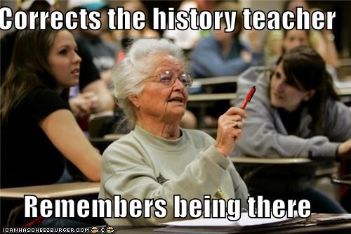

Stage 1 History

Popular Culture: Post WW2 in Australia
Resource:
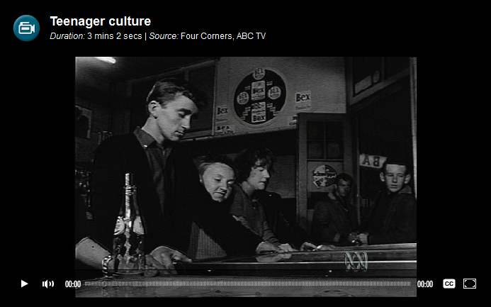
http://splash.abc.net.au/digibook/-/c/618362/popular-culture-post-war
Composition and nature of the class
The student cohort consists of fifteen students who have varied literacy skills and a keen interest in studying history at a public school. 8 students are female and 7 are male. They have a diverse range of learning styles and one student suffers from dyslexia. Only half of the class have studied History before and possess basic to advances source analysing skills. Their essay writing skills are sound and their research skills are developing. Most students enjoy the incorporation of ICT into the classes and watching videos, analysing sources and participating in group discussion.
History topic being taught
The topic for this unit is Australia in the 20th Century. For this lesson we are focusing on teenage culture post World War Two. Incorporating popular culture of the time, this lesson will look at the burst of rock and roll into the cultural landscape, bodgies and woodgies, impact on teenage culture on society and the way it was perceived in Australia.
The resource and its purpose
This resource is a short video from the ABC television show ‘Four Corners’ on Teenage Culture in post-war Australia. It looks at the introduction of ‘teenagers’ with the arrival of rock ‘n’ roll in Australia and how teenage culture introduced new and challenging forms of expression. The purpose of this video is for students to gain an understanding of what it was like to be a teenager in the mid-1950s and analyse how Australian society reacted to the new and rebellious culture form. The lesson will also use the source to compare teenagers in the video to teenagers prior to WW1 and todays.
The skill being addressed
The skill that is being addressed from this resource is source analysis (credibility/bias/secondary) and comparing the source to other sources from different stages in time. (E.g. video on teenagers in 1920’s and today)
What you hope to achieve
I hope to achieve a good class discussion about the source and what it demonstrated/doesn’t demonstrate about teenagers in the 1950s. Hopefully this will be a topic that students can relate to and debate the familiar statement “the next generation is always worse than ours”. I hope the class will question how this statement relates to the generation of post WW2 ‘teenagers’ and how and if it’s any different to today’s generations?

Stage 2 History

Topic 9: An Age of Catastrophes: Depression, Dictators, and the Second World War, c. 1929–45

Resource: Using Primary Sources: Nazi Spy Ring Busted
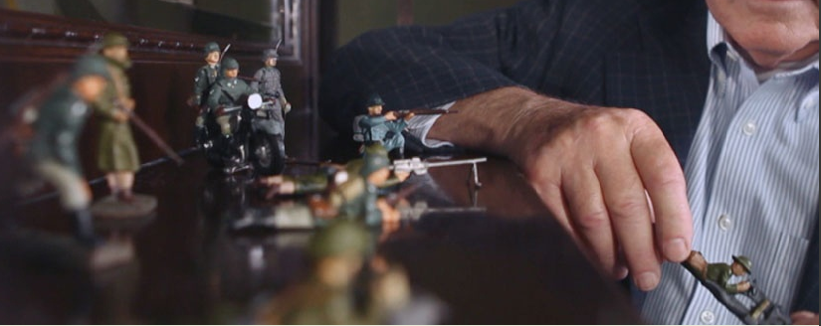
Resource link: (videos, worksheets, more detailed instructions)
http://www.pbs.org/opb/historydetectives/educators/lessonplan/using-primary-sources-nazi-spy-ring-busted/

Composition and nature of the class
The student cohort consists of seventeen students who have competent literacy skills and are passionate about studying history. 10 students are female and 7 are male. There is a diverse range of learning styles, but a majority of students are dedicated and high achievers. A number of the students studied history in year 11 and some hope to continue studying history at University. On average, their essay writing skills are strong, but they could always improve their source analysing skills.
History topic being taught
This unit is focusing on topic 9 of SACE: An Age of Catastrophes: Depression, Dictators, and the Second World War, c. 1929–45. This lesson concentrates on the nature of the dictators regime; being Hitler’s regime and how to thoroughly investigate and analyze a primary source.

The resource and its purpose
This resource is a class activity that determines biasness in primary sources. The resource uses a number of videos to investigate who is bias and what is bias and how this effects the investigation. After watching a few clips based around the event, the class will be devised into a number of groups to answer specific questions around interpreting the sources and investigating the event. The purpose of this resource if for students to put their current knowledge about investigating sources into practical use and explore sources/events in a way they never have before.
The skill being addressed
Practical source analysis and improving their ability to analyse, explore, investigate, think chronologically and explore a variety of sources. Students should improve their ability to accurately summarise the relationships between key details and ideas as well as evaluate different claims/evidence by challenging them with other information/sources.
What you hope to achieve
I hope to achieve an in depth knowledge in source analysing and exploring events and how events can change by different perspectives. I want students to be able to integrate information from diverse sources and cohort an understanding of an event or idea through these and interpret their biasness/eligibility.

